The Machine Learning Landscape

Machine Learning is the field of study that gives computers the ability to learn without being explicitly programmed.
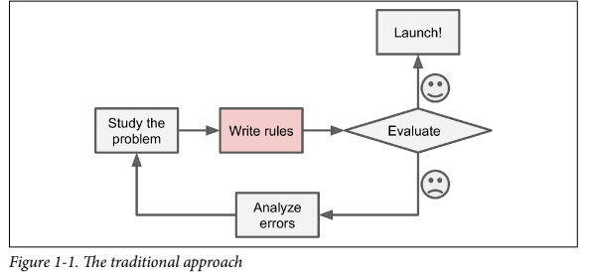
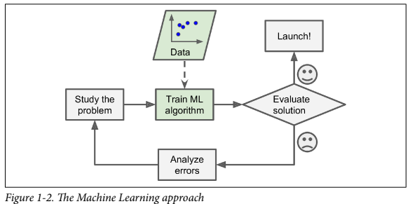
Applications of ML:
- Image Classification – CNN
- Detecting Tumors (Semantic Segmentation) – CNN
- NLP
- Text Summarization – NLP
- Speech Recognition
- Customer Segmentation – Clustering
Types of ML Algorithms:
- Supervised/Unsupervised Learning: Machine Learning systems can be classified according to the amount and type of supervision they get during training. There are four major categories: supervised learning, unsupervised learning, semisupervised learning, and Reinforcement Learning.

Supervised Learning Algorithms:
• k-Nearest Neighbors
• Linear Regression
• Logistic Regression
• Support Vector Machines (SVMs)
• Decision Trees and Random Forests
• Neural networks

Unsupervised Learning Algorithms:
• Clustering
— K-Means
— DBSCAN
— Hierarchical Cluster Analysis (HCA)
• Anomaly detection and novelty detection
— One-class SVM
— Isolation Forest
• Visualization and dimensionality reduction
— Principal Component Analysis (PCA)
— Kernel PCA
— Locally Linear Embedding (LLE)
— t-Distributed Stochastic Neighbor Embedding (t-SNE)
• Association rule learning
— Apriori
— Eclat
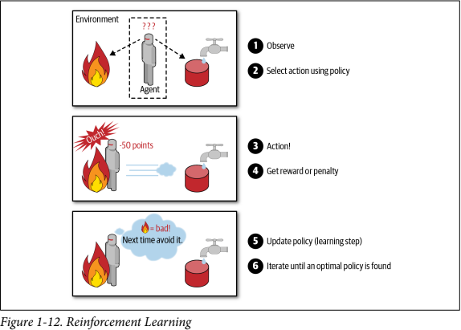

- Batch and Online Learning
In batch learning, the system is incapable of learning incrementally: it must be trained
using all the available data. This will generally take a lot of time and computing
resources, so it is typically done offline. First the system is trained, and then it is
launched into production and runs without learning anymore; it just applies what it
has learned. This is called offline learning.

In online learning, you train the system incrementally by feeding it data instances
sequentially, either individually or in small groups called mini-batches. Each learning
step is fast and cheap, so the system can learn about new data on the fly

Main Challenges of ML:
- Insufficient Quantity of Training Data
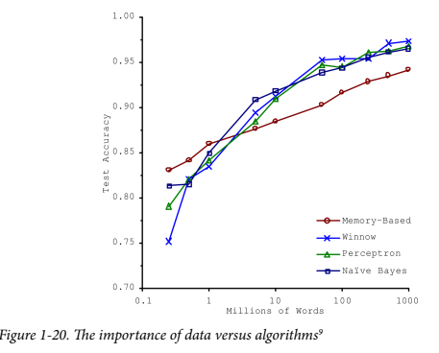
- Nonrepresentative Training Data
- Poor Quality of Data
- Irrelevant Features
- Say you are visiting a foreign country, and the taxi driver rips you off. You might be
tempted to say that all taxi drivers in that country are thieves. Overgeneralizing is
something that we humans do all too often, and unfortunately machines can fall into the same trap if we are not careful. In Machine Learning this is called overfitting: it means that the model performs well on the training data, but it does not generalize well.

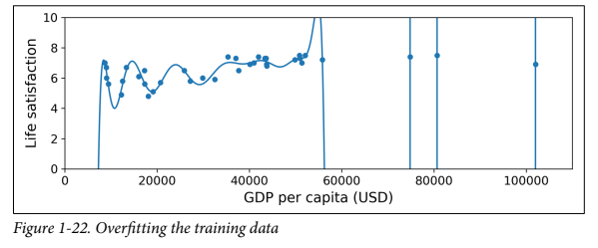
- As you might guess, underfitting is the opposite of overfitting: it occurs when your model is too simple to learn the underlying structure of the data.

Testing and Validating
- Split your data into two sets: the training set and the test set. As these names imply, you train your model using the training set, and you test it using the test set.
- If the training error is low (i.e., your model makes few mistakes on the training set) but the generalization error is high, it means that your model is overfitting the training data.

Hyperparameter Tuning and Model Selection
The problem is that you measured the generalization error multiple times on the test set, and you adapted the model and hyperparameters to produce the best model for that set. This means that the model is unlikely to perform as well on new data. A common solution to this problem is called holdout validation: you simply hold out part of the training set to evaluate several candidate models and select the best one. The new held-out set is called the validation set

